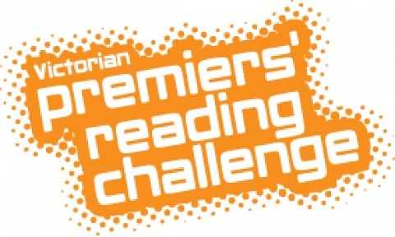
Victorian Premiers’ Reading Challenge 2019 is now on.

All you need to do is register as a challenger in the library and keep a record of your reading.
The librarian will collect your record, and put it online.
Good Luck!

